How Technology Can Help Adhere to Physical Activity Routine.
Technological improvements have brought about reductions in the physical work that is required daily. The digital age has no doubt, eliminated the physical activities that were needed. Indoor lifestyle has been deemed the root of many prevalent chronic diseases, including heart disease and diabetes. However, using technology while indoors is a best and alternative opportunity in increasing physical activity. Some researchers have noted that mobile phone applications, pedometers and video games can be used to increase energy disbursement. Below are practical ideas that one can adhere to daily physical activities.
Smartphones apps
With the changes in mobile phone technology, smartphones have now become like mini personal computers. There are over 17,000 health and fitness related applications available. More than 1billion people are using the apps. A typical smartphone user uses about 2 hours on applications per day. There is an excellent potential for the devices to aid in the promotion of many positive, healthy behaviour changes which include an increased physical activity. The use of smartphone technology in self-monitor physical activity has been promising. Installed activity apps record at least 10,000 daily steps by the phone users, thus having a smartphone application increases the duration and quality of commitment in the intervention due to the heightened convenience of the smartphone application.

Active Video Games
A lot of screen time for both adults and children is not all that good. It has been linked to cardiovascular disease, hypertension and obesity. Interventions for reducing screen time have not been entirely that successful because people are so addicted to the activity and do not want to give it up. The active video games have made it possible for players to interact physically through the arm, leg or the whole-body movements with on-screen images in many activities and sports: tennis, boxing, walking and soccer. Notably, there are also video games, including Nintendo Wii and Verbeke. Video games can be used to increase daily energy commitment levels. For the middle age people, playing Wii video games is a substitute of aerobic exercise which helps in maintaining and improving cardiorespiratory fitness as well as improving balance in older adults and modifying the body composition of children positively.
Featured Image
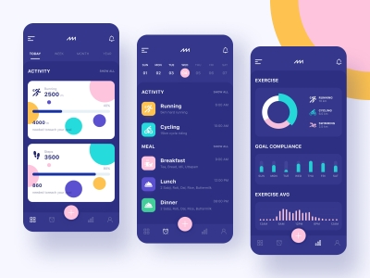

Other Images


Links
https://www.acefitness.org/
https://bmcpublichealth.biomedcentral.com/articles/10.1186/s12889-015-1968-y

